(Approx. 653 words)

AcuRite Pro 5-in-1 Weather Station
By Jerry Grommes, Editor, Sandwich Computer Users Group, IL
www.scug.org
ggrommes (at) live.com

I recently received an email from “Score Card Rewards” telling me how many points I had accumulated (purchasing with my VISA earns points which can be used to purchase merchandise through Score Card Rewards). I thought what better way to get a new gadget than to burn some points. Looking through the Score Card Rewards online catalog I came across something I had wanted for some time, but did not want to spend money on, a personal weather Station. I promptly added it to the cart & checked out.

The AcuRite Pro 5-in-1 Weather Station with PRO+ 5-in-1 Sensor, PC Connect, Wind and Rain arrived 3 days later. I was a “Happy Camper” and had it setup and running in just a couple of hours. http://www.acurite.com/pro-5-in-1-weather-station-with-pro-5-in-1-sensor-pc-connect-wind-and-rain-01035p.html

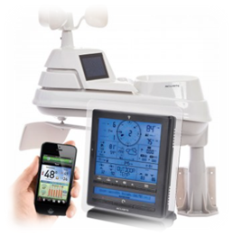
The weather display with AcuRite Connect plugs into your computer to store, track and share your weather information. You can view your sensors from virtually anywhere on a smartphone, tablet or computer with the AcuRite app and myAcuRite.com website, or you can easily publish your weather reports on Weather Underground.

Good Support
Initially I had an issue adding my device to the AcuRite website, so I placed a call to customer support which the automated call service stated that I was in a que with 8 ahead of me. It then offered me to stay on hold and wait in line or to give a call back number and they would call me back when it was my turn. I opted with the call back and received their call about 45 minutes later.

The support person was very well versed, easy to understand and took care of my problem in a matter of minutes. The contact us support page lists the Company (Chaney Instrument Co.) as being located in Lake Geneva, WI. That’s almost local.

AcuRite Pro 5-in-1 Weather Sensor
- Measures temperature, humidity, wind speed, wind direction and rain
- Two solar panels power the internal fan to maximize ambient temperature accuracy at all hours of the day (standard 5-in-1 includes only one solar panel)
- Strong wireless range up to 330 feet (100 meters)
- Transmits data every 18 to 36 seconds
- Automatic self-emptying rain collection cup
- 2 year battery life
- Durable, all-weather construction
- Easy installation includes mounting hardware

Pro Weather Station Includes: Digital Display with PC Connect for 5-in-1 Sensor Data, 5-in-1 PRO+ Weather Sensor, USB cable, mounting bracket, mounting hardware, AC power adapter, instruction manual

Display with PC Connect for 5-in-1 Sensor
- 12 to 24 hour weather forecast
- Patented Self-Calibrating Forecasting pulls data from a sensor in your backyard to give you the most accurate forecast for your exact location
- Weather Ticker™ streams real-time information and alerts
- Programmable weather alarms: temperature, humidity, wind, rain, dew point, heat index and storm alerts
- Measures rain precipitation and rainfall history (inches or millimeters)
- Wind speed: current, peak, and average (MPH or KPH)
- Wind direction with 16 point wind rose
- Indoor and outdoor temperature (degrees Fahrenheit and Celsius) with trend arrow
- Indoor and outdoor humidity (%RH) with trend arrow
- Heat index, wind chill, dew point and "feels like" calculations
- Daily, weekly, monthly and annual high and low records
- Barometric pressure with trend arrow
- Time and date (month/day)
- Bright blue backlight
- Bilingual English or French display
- Tabletop or wall-mountable design
- Indicator for wireless sensor signal strength

I am currently publishing my weather data on Weather Underground and you can view it at:
http://www.wunderground.com/weather-forecast/zmw:60545.1.99999
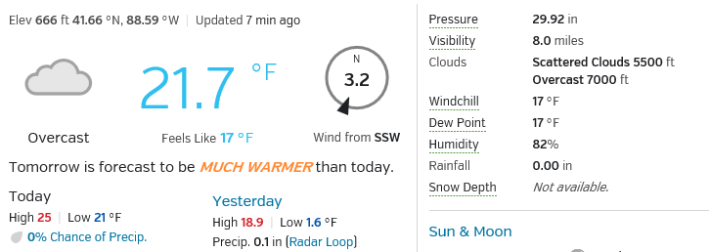

Or you can check it out at the bottom of the SCUG Home Page: http://www.scug.org/
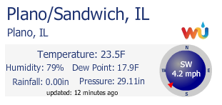

Weather Underground was founded in 1995 as the first online weather service, Weather Underground supplies weather data solutions to the many of the leading media companies and millions of users across the globe through their mobile apps and website wunderground.com. With over 180,000+ personal weather stations worldwide, Weather Underground is able to provide meaningful and reliable weather data to people in real-time. Weather Underground is part of The Weather Company and is based in San Francisco, California.

